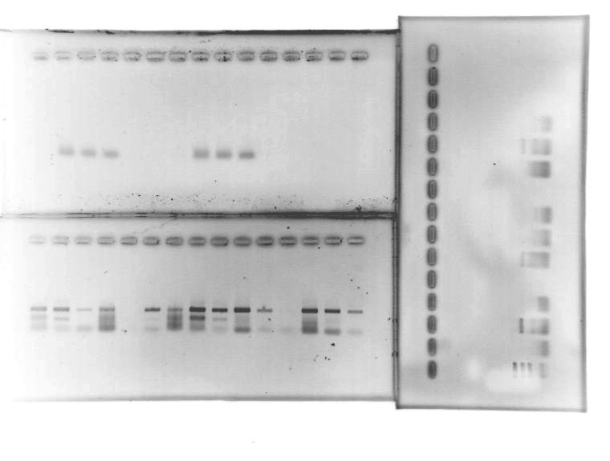

Upper left gel:
TopTaq Master Mix

Bottom left gel:
HotStarTaq Plus Master Mix
Sets of 3 with annealing temps of 43, 52, and 58°C.
Mouse DNA with 1.5 mM MgCl₂, Mouse DNA with 2.5 MgCl₂, Mouse DNA with 5 mM MgCl₂, Bat DNA with 1.5 mM MgCl2, Bat DNA with 2.5 MgCl₂.

Right gel:
TopTaq DNA Polymerase with 10x Buffer
Same mouse samples as listed for bottom left gel.

